**Lab 3 : Entity Relationship Modeling**FALL 2021

1. Consider the following scenario for Skylark Travel Airlines which provides the context of the relational database that follows. Then answer the questions based on them (10 points).

*Skylark Travel Airlines has to keep track of its flight and airplane history. A flight is uniquely identified by the combination of a flight number and a date. Every passenger who has flown on Skylark Travel has a unique passenger number. For a particular passenger who has taken a particular flight, the company wants to keep track of the fare that she paid for it and the date that she made the reservation for it. Clearly, a passenger may have taken many flights (he must have taken at least one to be in the database) and every flight has had many passengers on it.A pilot is identified by a unique pilot (or employee) number. A flight on a particular date has exactly one pilot. Each pilot has typically flown many flights but a pilot may be new to the company, is in training, and has not flown any flights, yet. Each airplane has a unique serial number. A flight on a particular date used one airplane. Each airplane has flown on many flights and dates, but a new airplane may not have been used at all, yet.*

*Below shows the relational tables designed for Skylark Travel Airlines.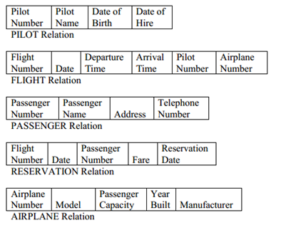*

1. *(2 points)* Identify the candidate keys of each relation.

PILOT: Pilot number + Pilot name

FLIGHT: Flight number

PASSENGER: Passenger number + Passenger name

RESERVATION: Flight number + Passenger number + Reservation date

AIRPLANE: Airplane number

b) *(2 points)* Identify the primary key and any alternate keys of each relation.

PILOT:

* Primary: Pilot number
* Alternate: Pilot name

FLIGHT: Flight number

PASSENGER:

* Primary: Passenger number
* Alternate: Passenger name

RESERVATION: Flight number + Passenger number + Reservation date

AIRPLANE: Airplane number

1. *(2 points)* How many foreign keys does each relation have?

PILOT: 0

FLIGHT: 1

PASSENGER: 0

RESERVATION: 2

AIRPLANE: 0

1. *(2 points)* Identify the foreign keys of each relation.

FLIGHT: Airplane number

RESERVATION: Flight number + Passenger number

1. *(2 points)* Identify the relations that support many-to-many relationships, the primary keys of those relations, and any intersection data.

Passenger and flights.

Primary key:

* passenger: Passenger number + Passenger name
* Flights: flight number

Intersection data:

* + Passenger: address and telephone number
  + Flights: Departure time and Arrival time

g) *Write SQL commands to: (2 points each)*

* 1. Retrieve the record for airplane number 36325.

SELECT*FROM Airplane WHERE airplane_number = 36325

* 1. Retrieve the record for the pilot named Sarah Johnson who was born on 5/22/1959.

SELECT*FROM Pilot WHERE pilot_name = “Sarah Johnson”, Date_of_birth = “5/22/1959”

* 1. List all of the airplanes manufactured by Boeing.

SELECT Airplane_number FROM Airplane WHERE manufacturer = “Boeing”

* 1. List the airplane number and passenger capacity of every airplane manufactured by Boeing in 1997 .

SELECT Airplane_number, passenger_capacity FROM Airplane WHERE manufacturer = “Boeing” , Year_built = 1997

* 1. List the airplane number, model, and manufacturer of every airplane.

SELECT Airplane_number, model, manufacturer FROM Airplane

* 1. What company manufactured airplane number 53489?

SELECT Manufacturer FROM Aiplane WHERE Airplane_number = 53489

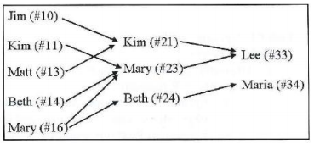

1. Figure above illustrates the “manager-subordinate” relationship of a company, where each employee has a name and unique 2-digit employee ID (e.g., #10). For instance, the arrow from Jim (#10) to Kim (#21) means that “Jim reports to Kim”. Note that there may be different employees with the same name spellings.

a) *(5 points)* Draw an ER Diagram that can capture the scenario of the figure. Note that your cardinality/modality must be faithfully based on the figure.

b) *(5 points)* Convert your ER Diagram of above question into relational tables and draw them in detail (i.e., table name, attribute names, rows in them, primary keys and foreign keys. Note that your table should not lose any information that is on the above figure.